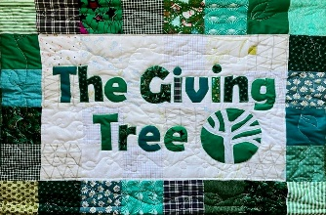
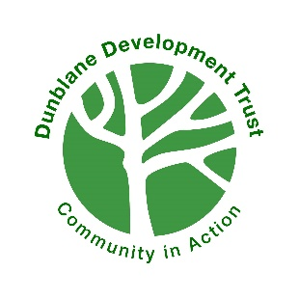
Dunblane Development Trust Small Community Grant
Fund Application Form
Due to the continued success of The Giving Tree, we are delighted to be able to reinvest its proceeds back into Dunblane through the Dunblane Development Trust Small Community Grants Fund (DDTSCGF).
PLEASE NOTE:
- Please read the grant criteria prior to completing the application form. The grant criteria can be viewed online at:
www.dunblanedevelopmenttrust.com
- Completed form should be sent by email to DDTcommunitygrantsfund@gmail.com
- Applications will be acknowledged by return and applicants will be notified of the recommendation in a timely manner. Those received after the deadline will be returned and will not be considered for an award.
- Awards will be made by the Dunblane Development Trust on the recommendation of the Dunblane Development Trust Small Community Grant Fund, a body comprising of representatives from the Dunblane Development Trust, The Giving Tree, Dunblane Community Council and the wider Dunblane community.

ABOUT YOUR GROUP
Name of group

Name of main contact in the group
Title: | First Name: | Surname:

Post held

Address for correspondence

Postcode | Telephone | Email

Have you made an application to the Braes ‘O’ Doune Wind Farm Fund in 2025? Yes/No
If yes, please tell us about the project you applied to the Wind Farm for?
PLEASE NOTE: If you have been successful in receiving a grant from the Braes ‘O’ Doune Wind Farm Fund in 2025, you may not apply to the DDT Small Community Grants Fund for the same project but may apply for an alternative project.

ABOUT THIS GRANT
What does your organisation do?

What does your organisation want to do with the grant from the DDT Small Community Grant Fund? Please also state when you expect to incur the relevant expenditure.

Which parts of the community will it benefit?

Please give a detailed breakdown of all the costs. Please make sure you support these costs with quotes, estimates or catalogue pages, planning and other statutory consents and landowner agreements where necessary.

Total Project costs

Total amount requested from fund

ABOUT YOUR FINANCIAL DETAILS
Please give us details of your group’s bank account or bank details of the organisation that is prepared to administer any monies on your behalf.
Group name on account

Bank / Building Society Name

Account number | Sort Code | Building Society number

Please give the name of the two bank signatories and their positions for your organisation or the organisation that is supporting you.
Name | Position
Name | Position

How many people are involved with your group?
Committee | Volunteers | Members | Paid Staff | Total Members

How many people will benefit from this project?

AGREEMENT

I confirm that to the best of my knowledge and belief all replies given on this application form are true and accurate. I understand that Dunblane Development Trust may collect supporting information at any stage of the application process. I further confirm that this application is made on the basis that if successful the organisation agrees to the following conditions: -
- Use the grant only for the purpose agreed in the offer letter.
- Complete an End of Project Report as requested.
- Provide detailed vouching and/or receipts for all relevant expenditure as requested.
- Return any unspent portion of the grant after 18 months or sooner when requested by the Trustees.
- Agree to any additional monitoring as required.
- If your group was to close within twelve months from receipt of a grant any unspent portion would be returned to the Trustees and any assets purchased with this grant will be given or transferred to another local volunteer organisation with similar aims and objectives.

Data Protection
The information given will be entered and processed on a company by the Dunblane Development Trust and the forms will also be kept. The information will be used by the Trustees and members of the Committee for administration purposes of the grant scheme. Personal data is limited to contact names, position, address, telephone and other contact details, organisation and project; it may be considered as sensitive personal data where the organisation / project is involved with matters relating to race, ethnic origins, politics, religious or similar beliefs, physical, mental health or sexual life.
Contact details will only be disclosed to third parties for the following purposes:
- to enable the Trustees to process your application
- to announce successful projects
- to promote the Dunblane Development Trust and the Dunblane Development Trust Small Community Grant Scheme generally via press releases and other bona fide promotional activities including placement on Dunblane Development Trust website and Social Media pages, local newspapers and or the dunblane.info community website.
Please sign to show that you agree to the grant conditions and to the Trustees and the Committee using your data in the above manner and that you have the right to withdraw consent to your data being used in this way at any time without detriment to your application.
I agree to the above use of my data, and I confirm that to the best of my knowledge and belief all replies given on this application form are true and accurate.

Signed by the contact | Date

Print name

Completed forms should be sent by email to DDTcommunitygrantsfund@gmail.com or can be posted to the Braeport Centre using the below address:
DDT Small Community Grants Fund,
Dunblane Development Trust,
Braeport Centre,
Braeport,
Dunblane,
FK15 0AT

