Volunteer Application Form
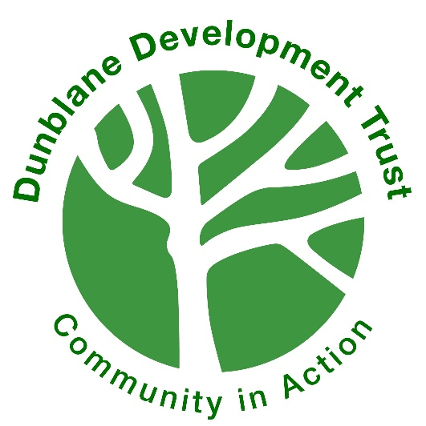
Volunteers make a vital contribution to the aims of Dunblane Development Trust
(DDT). We intend to encourage, develop and support volunteer involvement in our work. If you would like to volunteer with DDT please complete this form, and we will be in touch to discuss suitable opportunities. Please note that some of our projects (including those involving working closely with vulnerable adults or children) may require further application processes, such as PVG and reference check.

Contact Information
First name(s)
Surname |  | Date of birth
Address (including postcode) |  | Telephone
 |  | Mobile
 |  | Email

Emergency Details
Name and relationship |  | Phone number

Volunteering Opportunities
Is there is a specific volunteer group/role you wish to apply for?
Which of the following volunteering areas may be of interest to you? Please tick all that apply. | ☐ Admin ☐ Trustee ☐ Communication/social media ☐ Charity Shop (The Giving Tree) ☐ DIY ☐ E-bikes/active travel ☐ Events and social activities ☐ Dementia Friendly Dunblane ☐ Gardening/environment ☐ Health and wellbeing / befriender ☐ Work experience / DofE ☐ Youth/family projects ☐ Other, please specify______________
When would you like to volunteer? Please tick all that apply. | ☐ Weekday daytime ☐ Weekday evening ☐ Weekend daytime ☐ Weekend evening ☐ One-off volunteering projects/events ☐ Bespoke opportunities (no set hours) ☐ Other, please specify______________
Are there any specific skills, experience, training or expertise that you could offer DDT?
Would you require any additional support or adaptations to carry out volunteering roles with DDT?
Where did you hear about volunteering opportunities at DDT?

Referees
If you are applying for a role with Dementia Friendly Dunblane or The Giving Tree charity shop please provide the names and addresses of two people who can comment on your suitability for this volunteer role. We will seek your permission before obtaining references.
Referee 1
Full name
Address (including postcode) |  | Email
 |  | Mobile
Referee 2
Full name
Address (including postcode) |  | Email
 |  | Mobile

Criminal Convictions
Do you have any convictions which are unspent under the Rehabilitation of Offenders Act 1974? Yes ☐ No ☐

Having a conviction will not necessarily prevent you from volunteering with DDT – this can be discussed as part of the volunteer recruitment process.

Data sharing
Would you like to receive Dunblane Development Trust volunteer newsletters? | ☐ Yes | ☐ No
Are you happy for photos and film to be taken at volunteer projects for internal and external use – including newsletters, reports, presentations, leaflets and social media? | ☐ Yes | ☐ No

Volunteer Agreement
To make sure you have the best experience, we have created a volunteer letter which sets out our commitment to you and what we hope you can contribute. Please read this and confirm that you are happy to agree to follow this guidance. | ☐ I have read and agree to the volunteer letter guidance.

The personal information given on this form will be treated in confidence and only used to support your volunteering role(s) at DDT. Information will not be disclosed to any third parties except where permitted by law or where consent has been given. Application forms will be stored in a locked cabinet and in a spreadsheet with restricted access. Access to your data will be restricted to necessary named staff and board members. We will retain your details for the duration of your volunteering with DDT and for a further five years.

The information I have provided on this application form is true and complete. I understand that any information later discovered to be incorrect may result in my volunteer role ending. I am aware that I am responsible for notifying DDT of any changes to this information, and for ensuring that information is complete and correct. I am aware that I am able to access, according to the Data Protection Act 1998, the information regarding my personal data that is kept by the Dunblane Development Trust, by providing a written request. I can also request the correction, addition or elimination of any data through this written request.
Signature: |  | Date:

Equal opportunities

Dunblane Development Trust keeps a record of equal opportunities data in order to ensure that there is no discrimination at any stage of our volunteer recruitment process, and that we can record and improve our current practice. We would therefore be grateful if you would complete the questions on this form.

The data you provide is subject to the provisions of the Data Protection Act 1998. By completing this form and returning it to us, whether electronically or by hand, you are giving your permission for us to process the data for equal opportunities monitoring purposes. This information will be held confidentially and will only be used for the purposes of equal opportunities monitoring. This data will be kept separately from the application forms.

You can choose not to fill in any or all of the sections, and whether or not you choose to do so will have no effect on your application to volunteer with us.

Age | ☐ 16 - 18  ☐ 19 - 29  ☐ 30 - 44  ☐ 45 - 59 | ☐ 60 - 74  ☐ 75+  ☐ 75 - 84  ☐ 85+
Gender | ☐ Female ☐ Male  ☐ Other, please state …………………………………………
Do you consider yourself to have a long-term health issue or disability? | ☐ Yes ☐ No
What is your ethnic group? | ☐ Asian / Asian British  ☐ Black / African / Caribbean / Black British  ☐ Mixed / Multiple ethnic groups  ☐ White  ☐ Other ethnic group, please specify………………………………………
What is your religion? | ☐ No religion  ☐ Christian  ☐ Buddhist  ☐ Hindu | ☐ Jewish  ☐ Muslim  ☐ Sikh  ☐ Other, please specify………………
What is your employment status? | ☐ Student  ☐ Unemployed  ☐ Employed (full time)  ☐ Employed (part time)  ☐ Retired | ☐ Looking after home / family  ☐ Not working due to sickness / disability  ☐ Other, please specify…………….
What is your postcode? (for Scottish Index of Multiple Deprivation monitoring)

