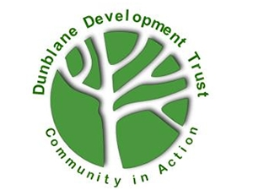
The Giving Tree Volunteer Shop Assistant
Dunblane Development Trust

Opportunity Name
The Giving Tree Volunteer Shop Assistant

Opportunity Description
We are looking for someone to help in the shop with sorting donations, providing customer service and handling sales.

Key tasks
- To sort and process donated stock including steaming, cleaning, and pricing donated items.
- To keep the sorting room organised and tidy.
- To handle cash and operate the till.
- To replenish stock on the shop floor and display items in an appealing way.
- To ensure the shop floor is kept clean and tidy.
- To provide excellent customer service.
- To promote the work of the charity.
- To adhere to shop procedures and policies.
- To participate in training.

Benefits and perks
The chance to build your work experience, develop your retail and customer service skills, work as part of a team and boost your self confidence. A friendly welcome, and mentoring/training as required. When working at the Shop a Giving Tree apron can be provided to help protect clothes. Volunteers at The Giving Tree also benefit from being part of the wider Dunblane Development Trust, including Volunteer Events.

Skills, training or qualifications required
- Good organisational skills.
- Friendly with good communication skills.
- A team player
- Be enthusiastic and willing to learn.

Is opportunity accessible?
Yes

Location of volunteering
The Giving Tree, 27 High St, Dunblane, FK15 0EE

Who will take responsibility for managing this volunteer post
Shop Manager at The Giving Tree
Does the role require a PVG check or reference check?
Reference checks

Is this an ongoing or one-off opportunity?
Ongoing

