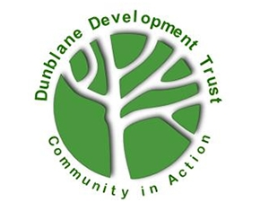
The Giving Tree eBay Sales Volunteer
Dunblane Development Trust

Opportunity Name
The Giving Tree eBay Sales Volunteer

Opportunity Description
We are looking for someone to help us sell high value items online.

Key tasks
- Sorting and selecting high value items from stock donations
- Prepare the product ensuring it is clean and presented at its best.
- Research the item looking at prices and demand.
- Take high quality photographs that highlight the product features as well as accurately highlighting any flaws so that the customer is fully aware of the condition of the item.
- Draft the listing to attract bidders and maximise sales
- Post the listing after the approval of the manager/supervisor
- Monitor listings to see if there is interest in the item and modify as necessary
- Package and send the item in a timely manner and ensure receipt of the item.
- Keep the shared drive up to date with details of the sale.

Benefits and perks
Valuable work experience in admin and team work. A friendly welcome, and mentoring/training as required. Volunteers at The Giving Tree also benefit from being part of the wider Dunblane Development Trust, including Volunteer Events.

Skills, training or qualifications required
Experience of using eBay and a good level of IT and literacy skills are required. Photography skills would be useful.

Is opportunity accessible?
Yes

Location of volunteering
Flexible – the volunteer will have to visit The Giving Tree (27 High St, Dunblane, FK15 0EE) to sort stock and take photos, but the online aspect of the role could be done from home.

Who will take responsibility for managing this volunteer post
Shop Manager at The Giving Tree
Does the role require a PVG check or reference check?
Reference checks

Is this an ongoing or one-off opportunity?
Ongoing

