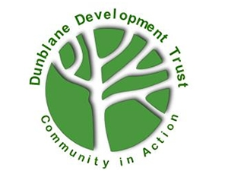
Environment Group Volunteer
Dunblane Development Trust

Opportunity Name
Environment Group Volunteer

Opportunity Description
We are looking for enthusiastic volunteers with an interest in working on various outdoor projects to improve the environment of Dunblane for its residents and visitors. We meet at the War Memorial Garden on Wednesdays at 9.30 until around 11.30, and participants are welcome to come for all or part of this time. The group leader sends out an email list of proposed tasks on a weekly basis, and volunteers opt in for the weeks they are able to attend. The group create and maintain some of the garden areas around Dunblane using nature-friendly and sustainable techniques, as well as helping with other outdoor projects such as the community orchard, paths and signs. This opportunity is suitable for all age groups and abilities, and we always welcome new volunteers and fresh ideas.

Benefits and perks
A friendly welcome, DDT clothing provided, and mentoring/training as required. We welcome people who have knowledge and experience that they are willing to share with the group, as well as offering support and encouragement for people wanting to learn new skills. This is a fantastic opportunity to make a positive contribution to the environment in Dunblane. Volunteers joining the Environment Group also benefit from being part of the wider Dunblane Development Trust, including Volunteer Events.

Skills, training or qualifications required
None required (although people with skills and experience to share are very welcome)

Is opportunity accessible?
Yes (limited due to outside location – contact us for more information)

Location of volunteering
Meeting point is usually Dunblane War Memorial, but projects are across Dunblane

Who will take responsibility for managing this volunteer post
Environment Group Leader
Does the role require a PVG check or reference check?
No

Is this an ongoing or one-off opportunity?
Ongoing

