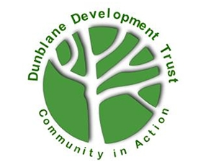
DIY Group Volunteer
Dunblane Development Trust

Opportunity Name
DIY Volunteer

Opportunity Description
The Mid-week DIY group was established in 2003 and has been involved with the following
activities since then:
- Maintenance of the internal & external fabric of the Braeport Community Centre
- Maintenance of public seating, railings and footbridges in Dunblane
- Provision of the annual Christmas lights in the town centre
There are currently 15 members who meet regularly on Tuesday mornings after an emailed
briefing of work to be done a few days in advance. An outline programme of work for the
year is agreed at a formal annual planning meeting with project leadership shared within
the group. More information: Midweek group – DIY Team – Dunblane Development Trust

Benefits and perks
Sharing and learning practical skills with a friendly bunch of DIYers. All sessions come with
a coffee/tea break plus good cheery conversations about local and world affairs!
Personal protective clothing is provided.

Skills, training or qualifications required
General domestic DIY skills preferred – painting & decorating, landscaping, woodwork,
metalwork, electrical, plumbing etc. There are many opportunities to share and develop
skills, sometimes in a formal manner but usually informally.

Is opportunity accessible?
Yes but rather limited.

Location of volunteering
We are based at the Braeport Community Centre where our materials and tools are
stored and where a dedicated workshop will be available from 2024. However much of
our community maintenance work is carried out on location throughout Dunblane.

Who will take responsibility for managing this volunteer post
The Development Trust Board appointed Group Team Leader
Does the role require a PVG check or reference check?
No

Is this an ongoing or one-off opportunity?
Ongoing

