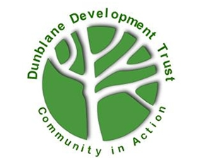
Memory Café Meeting Centre Volunteers
Dunblane Development Trust

Opportunity Name
Braeport Memory Café Meeting Centre Volunteer

Opportunity Description
Dementia Friendly Dunblane is a formal working group of Dunblane Development Trust. A steering group including individuals with the lived experience of dementia and their care partners work with businesses, schools & churches to raise awareness of dementia in the community.

We aim to support individuals with dementia and their care partners to live a fulfilled life in a supported community and to eradicate the stigma associated with dementia.

Volunteers are required to assist at the Braeport Memory Café Meeting Centre sessions. These supports individuals with dementia and their family carer to enjoy fun and stimulating activities in a supported environment. Volunteers can attend either of two weekly Meeting Centres at the Braeport Centre: Wednesdays from 1 to 4 pm and Fridays from 11 to 3 pm where lunch is provided.

Benefits and perks
Training and supervision will be provided. Tea and coffee provided. Volunteers for Dementia Friendly Dunblane also benefit from being part of the wider Dunblane Development Trust, including Volunteer Events.

Skills, training or qualifications required
We welcome volunteers who are friendly and compassionate. Previous experience of working with people with dementia is helpful. A good listener who can support carers going through challenging times.

Is opportunity accessible?
Yes

Location of volunteering
Braeport Centre Dunblane, FK150AT

Who will take responsibility for managing this volunteer post
Dementia Friendly Dunblane Project Coordinator
Does the role require a PVG check or reference check?
PVG and reference checks

Is this an ongoing or one-off opportunity?
Ongoing

